

**MASINDE MULIRO UNIVERSITY OF SCIENCE AND TECHNOLOGY**

**JACINTA GICHUHI**

**COM/0018/14**

**COMPUTER SCIENCE DEPARTMENT**

**COMPUTER ARCHTECTURE; CSC 321**

**ASSIGNMENT I**

**2nd MARCH 2017.**

1. **processors A and B have clock frequencies of 700 Mhz and 900 Mhz respectively. Suppose A can execute an instruction with an average of 3 steps and B can execute with an average of 5 steps. For the execution of the same instruction which processor is faster?**

Performance A =execution B

Performance B execution A

5/3=1.67

Processor A. This is found out using the Basic performance formula

1. **Compare and contrast ISA , ANSA and superscalar architectures for a given FINITE number of instructions to be executed ?**

**ISA –** Instruction Set Architecture is part of the processor that is visible to the programmer or compiler writer. It serve as the boundary between software and hardware.

**ANSA –**Advanced Network System Architecture.

**Superscalar architectures**

A superscalar architecture replicates each of the pipeline stages so that two or more instructions at the same stage of the pipeline can be processed simultaneously

1. **Explain performance suites and list 2**

These are stardandised set of programs that can be run on various architectures to complete their performance in certain areas such as kernel

Performance suites include:

Benchmark and MIPS.

1. **State an equation for speed-up due to pipeling in computer processing**

y->tasks/instructions

k->units

k+y-1->time units required to complete k tasks

speed = time using sequential processing

time using pipeline processing

speed = y x k x time

(k+y-1)time

1. **If a processor clock is rated as 1250 million cycles per second, then its clock period is:**

Period = 1/frequency

Clock period = 1/processor’s speed

Clock period = 1/1250000000

= 0.0000000008.

=8.0x10-1ns

1. **RISC and CISC stands for.**

RISC- Reduced Instruction Set Computers.

CISC – Complex Instruction Set Computers. It has a rich set of instructions and addressing modes as compared to RISC.

1. **Which method of representation has two representations for ’0′?**

Sign-magnitude representation has two representations for zero where one is positive and one for negative

1. **When we perform subtraction on -7 and 1 the answer in 2′s compliment form is**

2’s compliment is found and that is added to the number and the overflow is ignored.

The answer is 1000.

1. **Find the remainder if 1101 is used to divide 100010010**

**000010101**

**1101 100010010**

**-0000**

**10001**

**-1101**

**10000**

**-1101**

**1110**

**-1101**

**0001 Remainder is 0001 whose decimal equivalence is 1.**

1. **What is operating system? List 4 operating systems.**

This is a computer software that supports a computer's basic functions, such as scheduling tasks, executing applications, and controlling peripherals

An operating system (OS) is the software component of a computer system that is responsible for the management and coordination of activities and the sharing of the resources of the computer.

1. [Microsoft Windows](https://www.lifewire.com/windows-troubleshooting-4102769) (like [Windows 10](https://www.lifewire.com/windows-10-2626217), [Windows 8](https://www.lifewire.com/windows-8-2626235), [Windows 7](https://www.lifewire.com/windows-7-2626265), [Windows Vista](https://www.lifewire.com/windows-vista-2626311), and [Windows XP](https://www.lifewire.com/windows-xp-2626354))
2. [Apple's mac OS](https://www.lifewire.com/learn-how-macs-4102760) (formerly OS X)
3. open source operating system [Linux](https://www.lifewire.com/learn-how-linux-4102755)
4. Android OS
5. Chrome OS
6. **How do programs access the services of the operating system?**

Programs running in a machine can access the services offered by the OS via the following technique:

**System call.** This is the programmatic way in which a [computer program](https://en.wikipedia.org/wiki/Computer_program) requests a service from the [kernel](https://en.wikipedia.org/wiki/Kernel_(computing)) of the [operating system](https://en.wikipedia.org/wiki/Operating_system) it is executed on. This may include hardware-related services (for example, accessing a [hard disk drive](https://en.wikipedia.org/wiki/Hard_disk_drive)), creation and execution of new [processes](https://en.wikipedia.org/wiki/Process_(computing)), and communication with integral [kernel services](https://en.wikipedia.org/wiki/Kernel_service) such as [process scheduling](https://en.wikipedia.org/wiki/Process_scheduling). System calls provide an essential interface between a process and the operating system

1. **Draw the memory hierarchy scale of a computer and compare them in terms of cost,**

**speed OS access and size.**

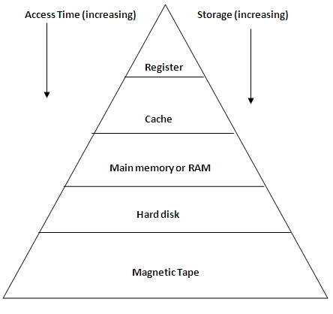

The storage and access time increases downwards from registers to magnetic tape.

The speed and of the storage devices increases upwards from magnetic tape to registers

1. **In IEEE single precision representations, the mantissa of the fraction occupies how many bits?**

The mantissa is made to occupy 23 bits, with 8 bit exponent as illustrated below.

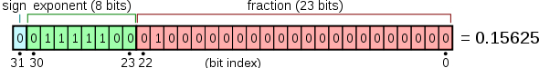

1. **The name given to the registers, ALU and the interconnecting path together is?**

A data path. This is the operational and processing part of the CPU.

1. **What do we use to reduce the memory access time?**

Cache’s memory are used to reduce the time needed to access part of the memory for data retrieval.